## Assignment - 4

|  |  |
| --- | --- |
| Assignment Date | 25 October 2022 |
| Student Name | SIVABALAN P |
| Student Roll Number | 812119104032 |
| Maximum Marks | 2 Marks |

**Question-1:**

Write a code and make a connection in wokwi for ultrasonic sensor. Whenever distance is less than 100 send ‘alert’ to ibm cloud and display in device recent events.

## Solution:

*Code:*

#include <WiFi.h>

#include <PubSubClient.h> WiFiClient wifiClient;

String data3;

#define ORG "4yi0vc"

#define DEVICE_TYPE "nodeMcu" #define DEVICE_ID "Assignment4" #define TOKEN "123456789"

#define speed 0.034

#define led 14

char server[] = ORG ".messaging.internetofthings.ibmcloud.com"; char publishTopic[] = "iot-2/evt/Data/fmt/json";

char topic[] = "iot-2/cmd/home/fmt/String"; char authMethod[] = "use-token-auth"; char token[] = TOKEN;

char clientId[] = "d:" ORG ":" DEVICE_TYPE ":" DEVICE_ID;

PubSubClient client(server, 1883, wifiClient); void publishData();

const int trigpin=5; const int echopin=18; String command; String data="";

long duration; float dist;

void setup()

{

Serial.begin(115200); pinMode(led, OUTPUT); pinMode(trigpin, OUTPUT); pinMode(echopin, INPUT);

wifiConnect(); mqttConnect();

}

void loop() {

bool isNearby = dist < 100; digitalWrite(led, isNearby);

publishData(); delay(500);

if (!client.loop()) { mqttConnect();

}

}

void wifiConnect() {

Serial.print("Connecting to "); Serial.print("Wifi"); WiFi.begin("Wokwi-GUEST", "", 6);

while (WiFi.status() != WL_CONNECTED) { delay(500);

Serial.print(".");

}

Serial.print("WiFi connected, IP address: "); Serial.println(WiFi.localIP());

}

void mqttConnect() {

if (!client.connected()) {

Serial.print("Reconnecting MQTT client to "); Serial.println(server); while (!client.connect(clientId, authMethod, token)) { Serial.print(".");

delay(500);

}

initManagedDevice(); Serial.println();

}

}

void initManagedDevice() { if (client.subscribe(topic)) {

// Serial.println(client.subscribe(topic)); Serial.println("IBM subscribe to cmd OK");

} else {

Serial.println("subscribe to cmd FAILED");

}

}

void publishData()

{

digitalWrite(trigpin,LOW); digitalWrite(trigpin,HIGH); delayMicroseconds(10); digitalWrite(trigpin,LOW); duration=pulseIn(echopin,HIGH); dist=duration*speed/2; if(dist<100){

String payload = "{\"Normal Distance\":"; payload += dist;

payload += "}";

Serial.print("\n"); Serial.print("Sending payload: "); Serial.println(payload);

if (client.publish(publishTopic, (char*) payload.c_str())) { Serial.println("Publish OK");

}

}

if(dist>101 && dist<111){

String payload = "{\"Alert distance\":"; payload += dist;

payload += "}";

Serial.print("\n"); Serial.print("Sending payload: "); Serial.println(payload);

if(client.publish(publishTopic, (char*) payload.c_str())) { Serial.println("Warning crosses 110cm -- it automaticaly of the loop"); digitalWrite(led,HIGH);

}else {

Serial.println("Publish FAILED");

}

}

}

void callback(char* subscribeTopic, byte* payload, unsigned int payloadLength){ Serial.print("callback invoked for topic:");

Serial.println(subscribeTopic); for(int i=0; i<payloadLength; i++){ dist += (char)payload[i];

}

Serial.println("data:"+ data3); if(data3=="lighton"){ Serial.println(data3); digitalWrite(led,HIGH);

}

data3="";

}

## WOKWI CODE:

<https://wokwi.com/projects/346937989346099796>

OUTPUT

# Distance is greater than 100

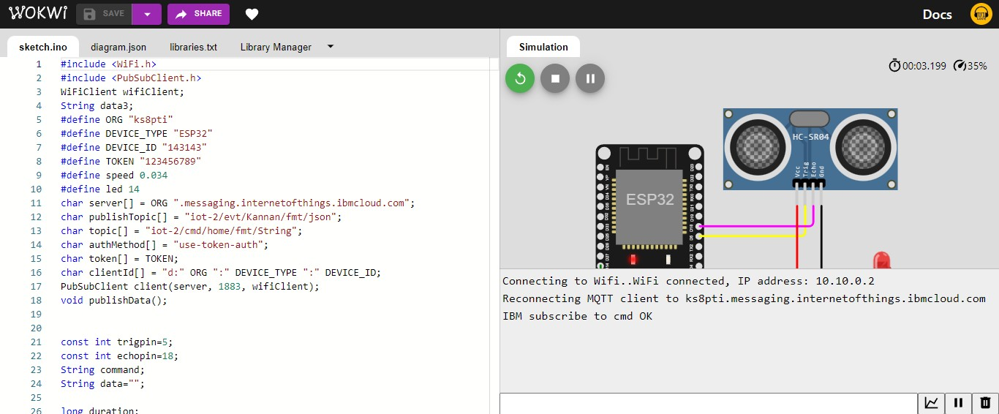

IBM cloud is connected and LED is off state

# Distance is less than 100

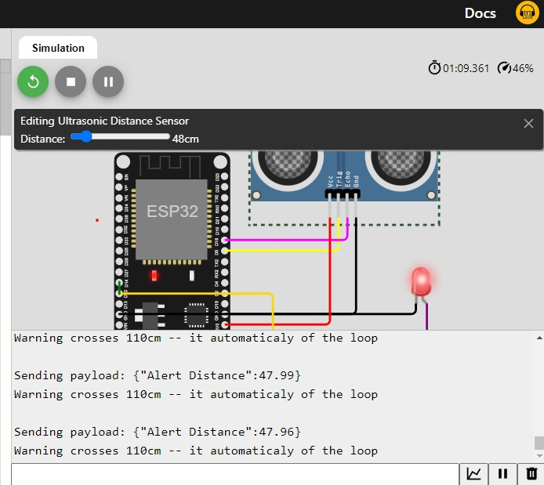

LED is on state

# IBM Cloud foundry connection

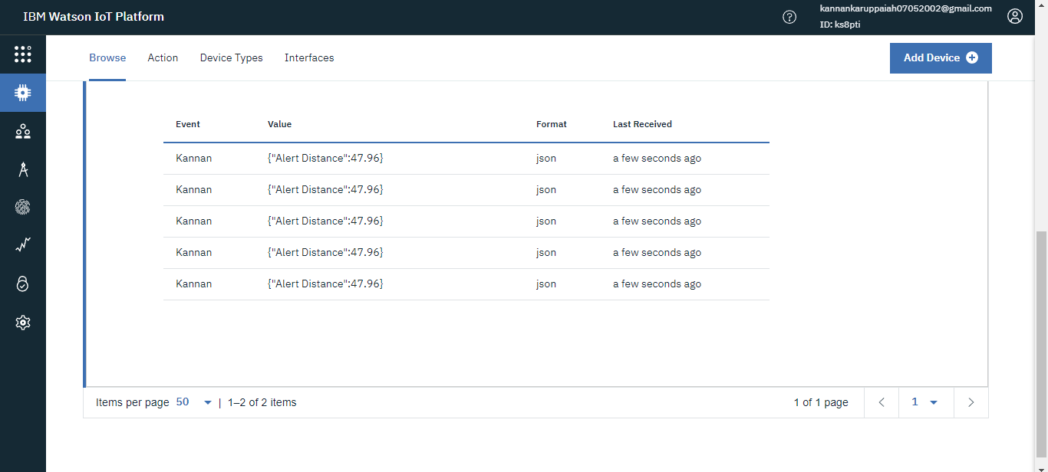

Getting alert message from wokwi